USER MANUAL FOR TrackMate

Once all the installation part is done, App icon will appear on the Home screen of the device.

Just click on it , You will see this screen:

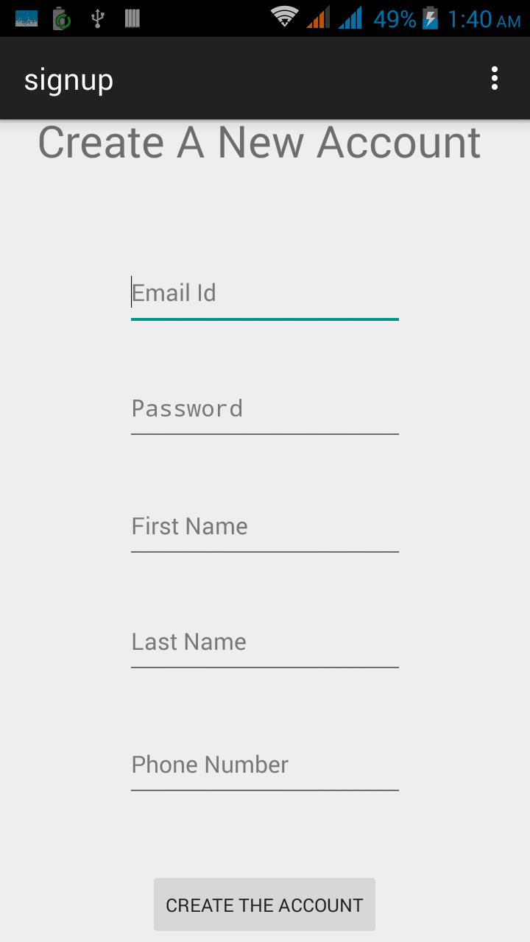

After successful account creation with valid Information, login activity is launched, which is as below:

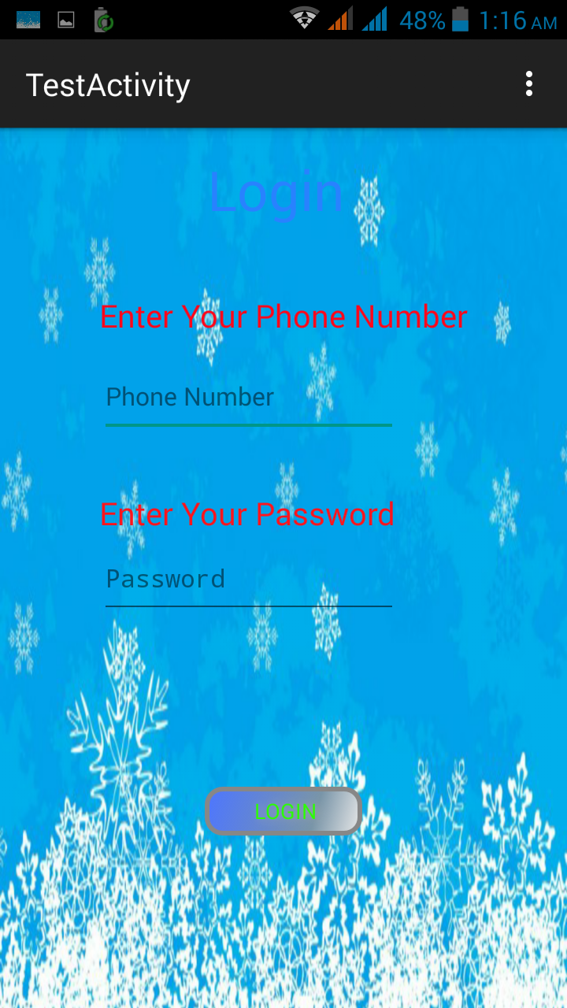

After Successful login, Welcome Screen is Launched which is shown below:

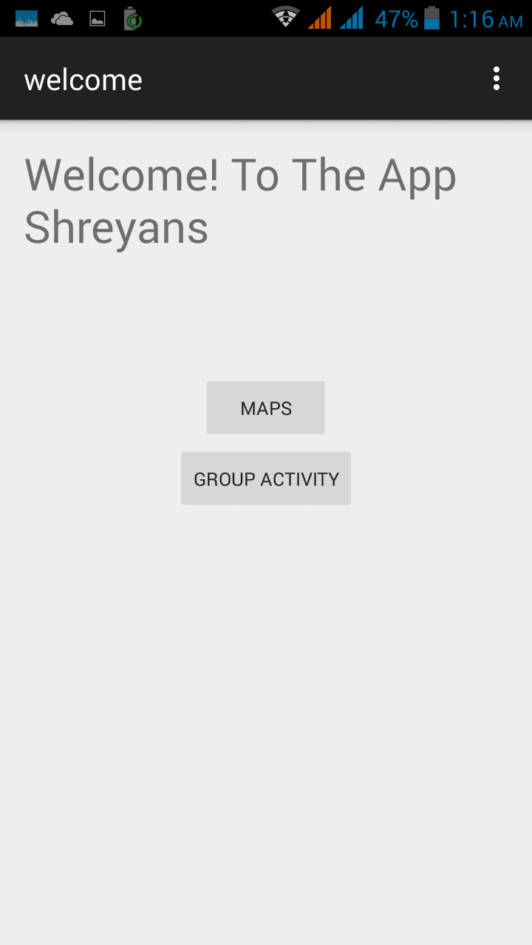

Next to create groups, click on Group Activity Button, then you will see this screen:

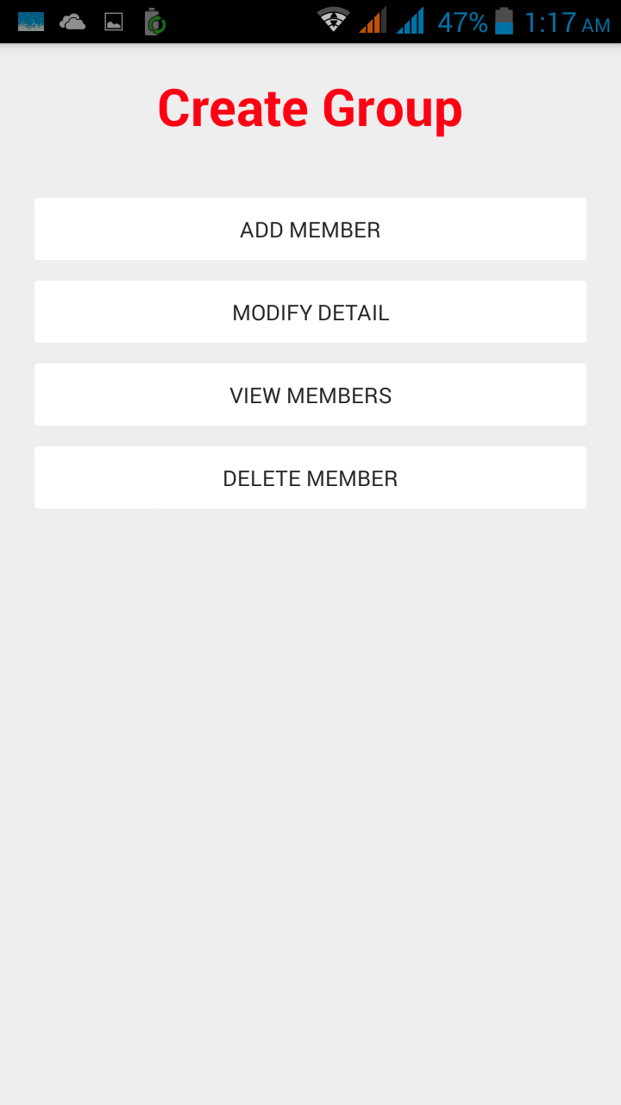

Next to add a new group member, click on add member button, then you will see this screen:

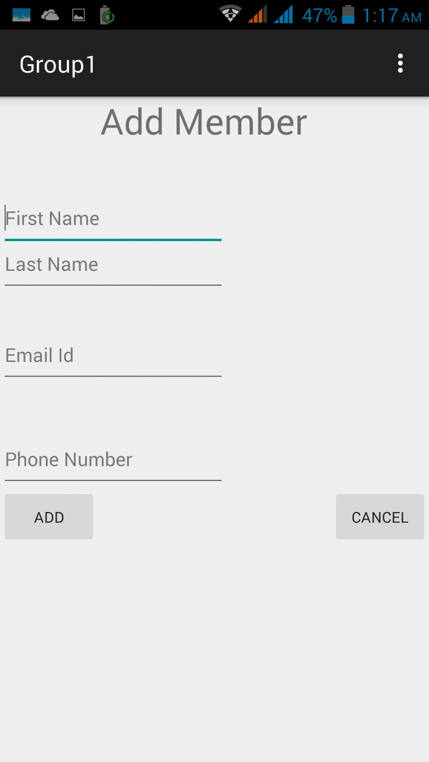

Now on the previous group activity, to modify the entered details about group members, click on modify detail button, after this you will see following screen:

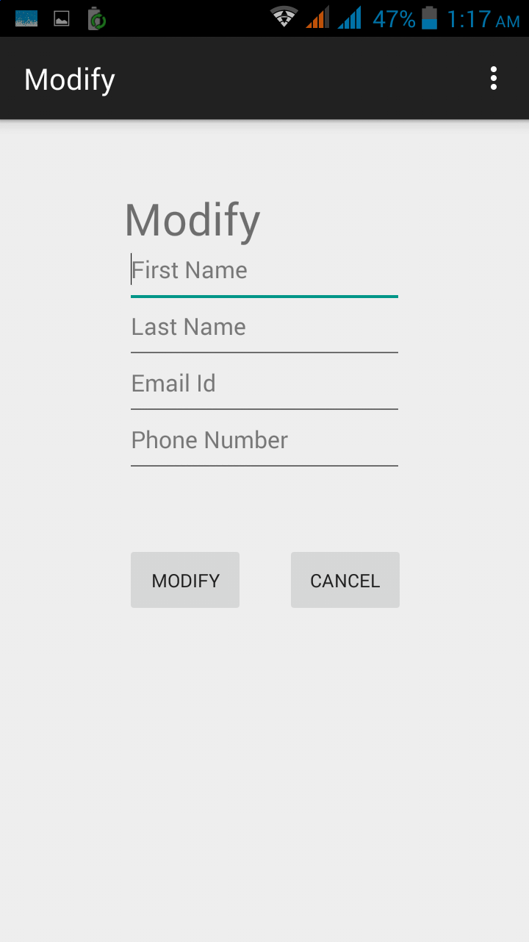

Again on the group Activity, click on the View Members button to view the registered group members, which as an example may look like this:

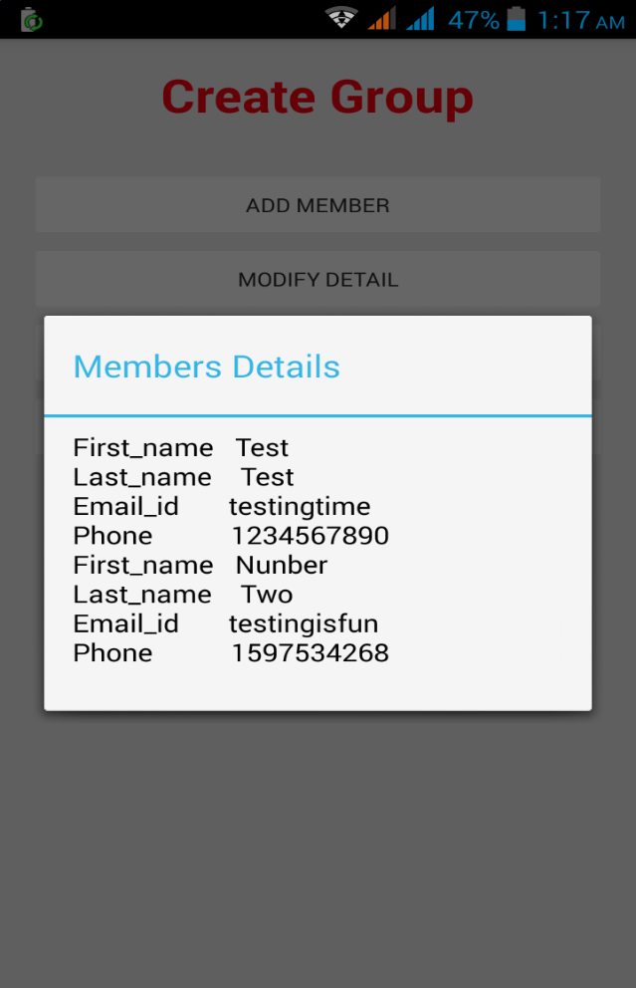

To delete a record, Simply Click on Delete Member Button, which takes you to the activity as shown below:

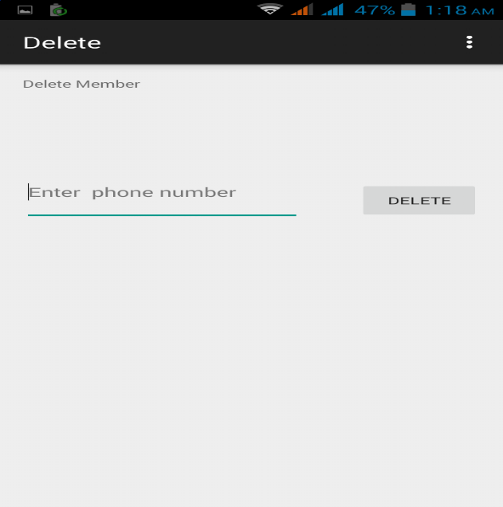

Now,Delete a group member by simply clicking on delete button.

Coming Back to the Welcome Page, Click on the ‘MAPS’ button to start the maps Activity, which looks as shown below:

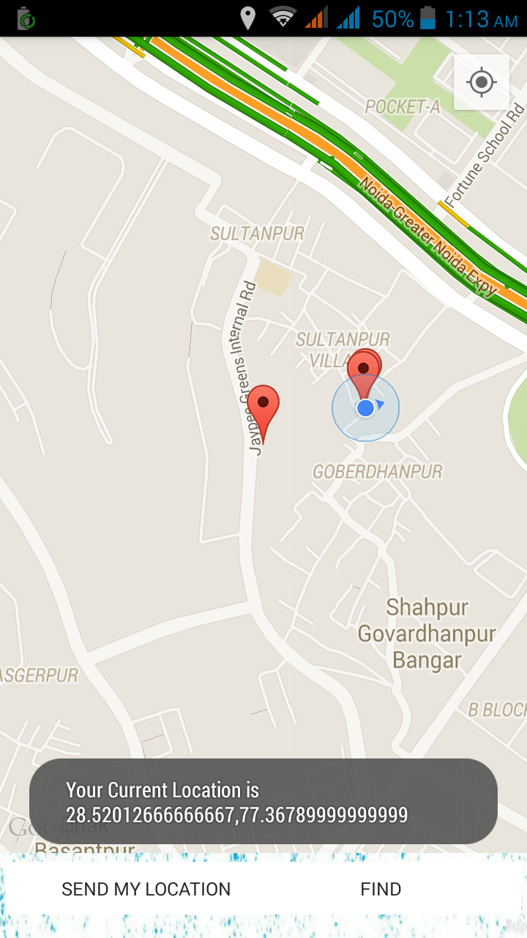

Now, to search for a location simply click on the ‘find’ button, which looks like:

